

CELEBRATE RAGGEDY ANN AND ANDY® WITH
SINGER-SONGWRITER-AUTHOR

PATTY HALL

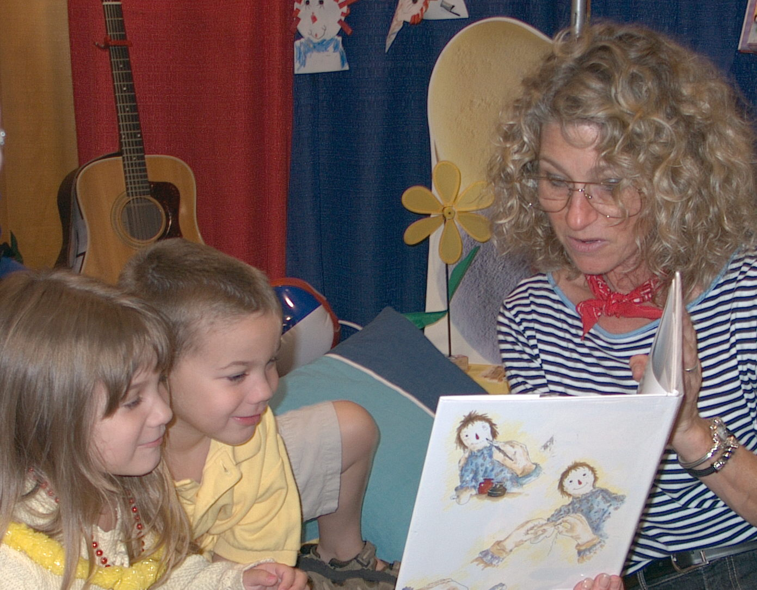

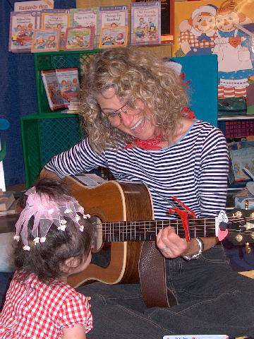
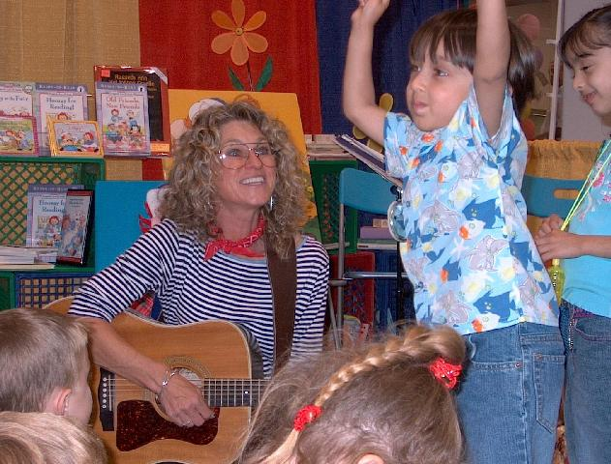

ORANGE COUNTY CHILDREN’S BOOK FESTIVAL
Sunday -- October 3, 2004
ORANGE COAST COLLEGE -- Costa Mesa, CA

RAGGEDY BOOKSIGNING
10:00 – 11:00 AM

Visit the BORDERS BOOKS booth to meet Patty, get signed copies of the Raggedy Ann and Andy® books she’s written, and learn more about her forthcoming Pelican book, THE HONEST-TO-GOODNESS STORY OF RAGGEDY ANDY, illustrated by Johnny Gruelle's granddaughter, Joni Gruelle Wannamaker, to be published in spring 2005.

Jumpin’ Up!™ Songs
Down-Home Music for Modern Kids
12:20 – 12:40 PM

Tune up your voices, put on your dancin’ shoes, and join Patty at the MAIN STAGE for her JUMPIN’ UP!™ SONGS, her own very special brand of kids’ music!

RAGGEDY ANN & ANDY® SONG
AND STORY TIME
Times/Locations TBA

Gather-round as Patty reads from her Raggedy Ann and Andy® books and shares more JUMPIN’ UP!™ and Raggedy songs

www.pattyhall.com

